Clinical Information Pack

Clinical Lecturer

|  |  |  |  |
| --- | --- | --- | --- |
| Post title: | **NIHR Clinical Lecturer in Paediatric Surgery** | | |
| School: | Human Development and Health | | |
| Faculty: | Faculty of Medicine (FoM) | | |
| Career Pathway: | Clinical | Level: | *AMNL/CADT |
| Salary: AMNL scale | £46,675 | To | £80,081 |
| Salary: CADT scale | £65,048 (ST3/CT3 to ST5) | To | £73,992 (ST6 to ST8) |
| Associated NHS Trust | University Hospital Southampton NHS Foundation Trust (UHS) | | |
| Clinical category: | Balanced portfolio | | |
| Posts responsible to: | Professor Nigel Hall, Professor of Paediatric Surgery | | |
| Posts responsible for: | Research Staff and Postgraduate Research Students as appropriate | | |

*\*AMNL scale to be used if candidate at or above ST3 on 3 August 2016*

*CADT scale to be used if candidate below ST3 on 3 August 2016*

**Particulars of Appointment**

The Faculty of Medicine wishes to appoint an NIHR Academic Clinical Lecturer, hosted by one of the following clinical specialties: Paediatric Surgery or Ophthalmology.

The post is intended for an applicant who is in medical training within either of these two specialties, with the specialty of the final (single) post dependent on the successful applicant.

The applicant will have a higher research degree (or have submitted for such a degree at the time of application) and appropriate research experience.

The post is subject to terms and conditions of service determined by the University of Southampton and in its honorary clinical capacity by the University Hospital Southampton Foundation Trust Board.

**This pack sets out the details for the post as it would be linked to Paediatric Surgery, should this be the specialty of the successful applicant.**

The post-holder will be pursuing their development of research and teaching within the Human Development and Health School of the Faculty of Medicine, University of Southampton.

In this post-doctoral role, the successful candidate will have substantial experience of the relevant research areas, a proven track record of high-quality original research publications, the ability to work well in a multidisciplinary, multi-professional team and hold a corresponding NTN.

**The University of Southampton**

The University of Southampton is a leading research-intensive University, a member of the Russell Group and one of the top 100 universities worldwide. We deliver an excellent educational experience, world-leading research and we are known for successfully commercialising that research through enterprise.

This is an exciting time to join the University of Southampton. We have an aspirational University Strategy (see [www.southampton.ac.uk/strategy](http://www.southampton.ac.uk/strategy)), setting out our ambitions over the next five years. The strategy involves achieving a top 10 place in the UK for research, which we will achieve by investing in the highest quality staff and facilities. We are also transforming the education offer available to undergraduate and postgraduate students across the University, providing greater flexibility and modular courses, with a strong international focus.

**The Faculty of Medicine**

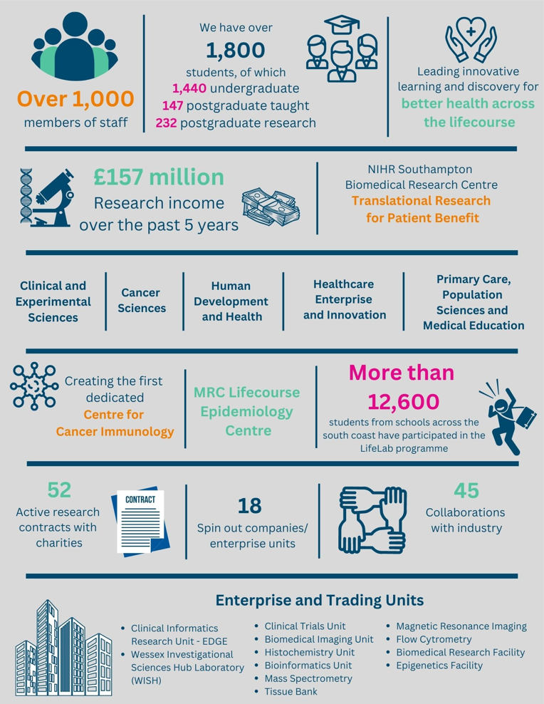

The creation of the Faculty of Medicine has enabled us to build upon strong foundations of basic research and clinical translation.  Working with colleagues across the University and in the local NHS we have strengthened our position as a renowned centre for translational research, leading innovative learning and discovery for better health across the life-course.  In this context, we are looking to appoint an outstanding senior academic to develop and lead a major programme of funded clinical research in the field of interstitial lung disease.

Key to the success of the Faculty of Medicine is the delivery of high-quality education for undergraduate and postgraduate students, building on our partnership in biomedical research with University Hospital Southampton NHS Foundation Trust and fostering new collaborations with the physical sciences, including chemistry, engineering and computing. The new senior academic in respiratory medicine will play a key role in these developments.

The Faculty celebrated its 40th anniversary in 2016. In 1971 FoM consisted of 40 students. FoM is now reputed for its excellence in research, innovative clinical teaching and is a vibrant pillar of the South of England community.

**The Student Experience**

We offer a range of undergraduate programmes: the BM4 programme, a graduate-entry four-year programme which accepts 48 students per year; and the BM5 and BMedSc programme which accepts 200 students per year including approximately 30 students from a BM6 programme aimed at widening access to a medical career. Students also join the first two years for teaching in Southampton on the BM(EU) Programme, an affiliation with a German Medical school in Kassel. Biomedical/ Psychosocial Teaching in the first two years of the BM programmes is delivered in the South Block of Southampton General Hospital as well as on Highfield campus. Clinical teaching takes place at Southampton General Hospital and the adjoining Princess Anne Hospital, the Royal South Hants Hospital, and in NHS Trusts and General Practices throughout Hampshire, Dorset, West Sussex and Salisbury.

The BM5 programme has a number of distinctive features.   These include the integrated nature of teaching where the scientific disciplines are taught together in a clinical context using a systems-based approach and the BMedSc programme, a four-month supervised research project undertaken in Year 3. There is also the opportunity, for selected students, to undertake an integrated, intercalated Masters in Medical Science (MMedSc).  The BM4 programme also has several key features.  These include clinical topics in the first two years where students meet on a regular basis in Graduate Groups and learning with BM5 students in the third and fourth years on all clinical attachments.  All students take the same final examinations.  All programmes have substantial clinical experience in the first two years, student selected components, dispersed final year attachments, work shadowing prior to commencing a Foundation post and inter-professional learning.

In addition to the undergraduate BM programmes the School provides four Masters Degree programmes in Public Health, Allergy, Genomics and Diabetes plus an MRres.

**Research and Enterprise**

The Faculty of Medicine has a clear research strategy to investigate the biomedical basis of common human diseases and to translate this into clinical practice. All research undertaken within the Faculty has clear evidence of international excellence and is delivered through appropriate Faculty Schools.

The Faculty of Medicine Enterprise Strategy is fully aligned to the University Enterprise Strategy to provide a step change to its enterprise and innovation culture, delivering global outreach, community engagement, innovative healthcare and policy. We work with all stakeholders from industry and pharma to health providers and the community.

**Equality, Diversity and Inclusivity**

We are committed to positively advancing equality of opportunity. We participate in a number of equality initiatives which celebrate good employment practice for the advancement of diversity, equality and inclusivity. These include the Stonewall Workplace Equality Index, the Race Equality Charter and Athena Swan, (for which we are currently silver award holders). We also have a number of staff equality committees who champion the advancement of equalities for diverse groups.



**Southampton Behaviours**

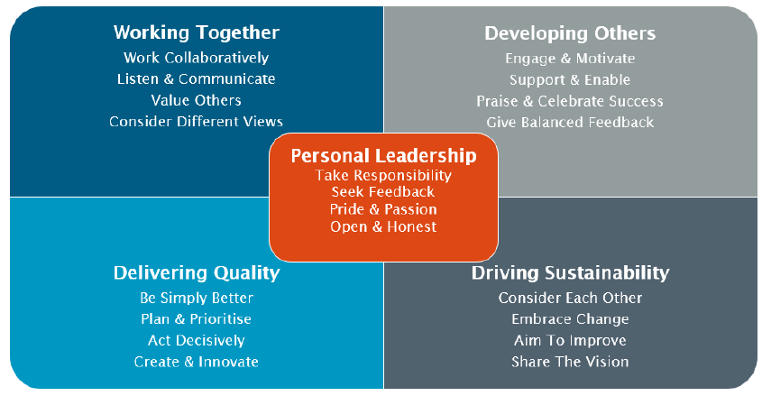

**School Information**

**Human Development & Health (HDH**

The medically qualified post-holder will join a team of researchers in the Department of Paediatric Surgery which sits within the School of Human Development & Health.

Within the school research focuses on the entire human life course from preconception to old age, to improve public health and patient outcomes and care.

Our main focus is on:

* the genetic basis of disease
* how epigenetics links lifestyle exposure to phenotype
* factors influencing healthy pregnancy outcomes and lifelong health
* how to achieve, maintain and restore musculoskeletal, cardiometabolic and immune/inflammatory health

**Our research**

We investigate mechanisms and test interventions, studying molecules, cells, individuals and populations. We are especially interested in musculoskeletal, metabolic, and immune/inflammatory health.  
  
Our 7 main themes of investigation each correspond with a research group.

**Cardiology**

Our research group’s work spans coronary and structural heart disease, rhythm abnormalities and pacing, as well as heart failure and complex devices. We are employing artificial intelligence models in several projects. We’ve 3 teams involved in both investigator-led and multicentre randomised trials such as FORECAST and RIPCORD2, as well as commercial projects:

**Developmental physiology and medicine**

Our work encompasses developmental processes from around conception into early childhood, the first 1,000 days. We aim to improve the scientific basis for medical interventions in this period to optimise reproductive success, newborn and childhood health and health across the lifecourse.

**Epigenetics**

We aim to understand how environmental influences on our genes affect the risk of disease throughout the lifecourse. Our researchers employ the latest cellular, molecular and bioinformatic approaches to study influences on the epigenome, from transcriptomics to machine learning. We develop novel interventions to promote healthy ageing and reduce ill-health.

**Global health**

We seek to foster a collaborative and interdisciplinary approach to research, education, and outreach in order to improve health equity and resilience and quality of life worldwide. Our research initiatives and collaborations advance knowledge, develop innovative solutions and nurture the next generation of leaders.

**Human genetics and genomic medicine**

Our research is centred around understanding the mechanisms of disease, using contemporary techniques and bioinformatics to identify and understand the basis of human disease. It also focuses on how research insights can best be used to benefit patients.

**Nutrition, endocrinology and metabolism**

Our researchers work to understand disease processes and to improve lifelong human health and wellbeing through research and innovation in the areas of nutrition, endocrinology and metabolism.

**Regenerative medicine and musculoskeletal science**

We focus on regenerative medicine and musculoskeletal science, exploring new technologies and treatments to promote the repair and regeneration of bones and cartilage. The group’s research cuts across the boundaries of the biological, medical and physical sciences.

**Paediatric Surgery at the University of Southampton**

The department is the leading unit for clinical research within the specialty in the United Kingdom and internationally recognised with a number of productive and impactful collaborations across Europe and North America.

We have extensive experience in the development and delivery of randomised controlled trials in Paediatric and Neonatal Surgery and in other prospective multicentre research collaborations. We have access to several robustly collated large multicentre clinical datasets allowing analysis of complex relationships between phenotype, treatment interventions and patient outcomes. Overall our research aims to have impact by improving clinical outcomes, quality of life and cost-effectiveness across a full range of paediatric and neonatal surgical conditions.

The department has strong track record of developing clinical academics providing a range of training and mentorship opportunities aimed at supporting a track toward research independence.

Candidates are encouraged to create collaborations with other members of the school and have conversations with theme leads to explore project ideas and proposals. Information can be provided by contacting Professor Nigel Hall (n.j.hall@soton.ac.uk) who will be able to help direct these.

**University Hospital Southampton NHS Foundation Trust (UHS)**

University Hospital Southampton NHS Foundation Trust provides services to some 1.9 million people living in Southampton and south Hampshire, plus specialist services such as neurosciences, cardiac services and children's intensive care to more than 3.7 million people in central southern England and the Channel Islands.

The Trust is also a major centre for teaching and research in association with the University of Southampton and partners including the Medical Research Council and Wellcome Trust.

UHS gained Foundation Trust status on 1 October 2011.

Every year 11,500 UHS staff:

* treat around 150,000 inpatients and day patients, including about 50,000 emergency admissions;
* sees over 624,000 people at outpatient appointments; and
* deals with around 135,000 cases in the [emergency department](http://www.uhs.nhs.uk/OurServices/Emergencymedicine/EmergencyDepartment.aspx).

Providing these services costs £1.9 million a day.

Job Description and Person Specification

|  |
| --- |
| Job purpose |
| The post-holder will have clinical commitments at University Hospitals Southampton NHS Foundation Trust (UHS) or other NHS Trusts in the London and Southeast Paediatric Surgery Training Consortium, as well as participating in the development of research and teaching within an appropriate research group of the Faculty of Medicine. The post is subject to terms and conditions of service, determined by the University of Southampton and in its honorary clinical capacity by the University Hospitals Southampton NHS Foundation Trust Board. |

|  |  |  |
| --- | --- | --- |
| Key Research accountabilities | | % Time |
|  | |  | | --- | | To develop and carry out an area of personal research. | | To disseminate findings in peer-reviewed journals, present results at conferences or exhibit work at appropriate events. | | To contribute to the writing of bids for research funding. | | Carry out administrative tasks associated with specified research funding, for example risk assessment of research activities, organisation of project meetings and documentation. Implementation of procedures required to ensure accurate and timely formal reporting and financial control. | | 35% |
|  | Key Education accountabilities |  |
|  | |  | | --- | | Support the teaching objectives of the School/Department by delivering teaching to students at undergraduate and/or postgraduate level, through allocated lectures, tutorials, practicals and seminars. | | Directly supervise students, providing advice on study skills and helping with learning problems. Identify the learning needs of students and define learning objectives. Set and mark coursework and exams, providing constructive feedback to students. |  |  | | --- | | Develop own teaching materials, methods and approaches, with guidance. Obtain and analyse feedback on own teaching design and delivery to facilitate this. | | Continually update own knowledge and understanding of subject area, incorporating knowledge of advances into own teaching contributions. | | 10% |

|  |  |  |
| --- | --- | --- |
|  | Key Management, Leadership and Engagement accountabilities |  |
|  | Contribute to the efficient management and administration of the School/Department by performing personal administrative duties as allocated by the Head, e.g. library representative, ethics committee representative etc. | 5% |
| Key Clinical accountabilities | | % Time |
| Clinical academic staff are managerially accountable for their clinical duties to the designated Program Director at University Hospital Southampton NHS Foundation Trust or another NHS Trust as directed by the Regional Training Programme Director.  On-call Arrangements  The exact nature of any on-call commitments to be undertaken will be agreed with the Trust within the job plan. | | 50% |

| Internal and External Relationships |
| --- |
| New appointees will be assigned a senior colleague to guide their development and aid their integration into the School/Department and university.    Research priorities will be agreed within the strategic framework of the research theme of which they are a member.  Teaching and administrative duties will be allocated by the Head of School/Department, within the context of the teaching programmes agreed by the School/Department Learning and Teaching Committee.  Other key relationships;   * Research Colleagues; * Head of School; * Central University Offices/Professional Services (e.g. Graduate Office, Finance, Research and Innovation services etc.); * Delivery of research presentations at national/international conferences and meetings; * Peer review of research outputs for national/international journals. |

| Staff Benefits |
| --- |
| Working at the University of Southampton gives you access to a wide range of benefits in addition to our competitive rates of pay. Our core benefits include pension scheme membership; a generous annual leave allowance (supplemented by University closure days and public holidays) and excellent family leave arrangements (including maternity, paternity, adoption and parental leave).   * Faculty Mentoring Scheme; * Ability to remain in NHS pension scheme, subject to qualifying criteria; * Discounted Sport and Wellbeing membership; * Access to private dental and/or healthcare insurance; * Cycle to work scheme * Tax-Free childcare |

**Person Specification**

|  |  |  |  |
| --- | --- | --- | --- |
| Criteria | Essential | Desirable | How to be assessed |
| Qualifications, knowledge and experience | Basic medical degree, MB BS (or equivalent qualifications)    Full GMC Registration  PhD/MD (or equivalent) in a research area relevant to the post. The applicant must have submitted their PhD or MD thesis at the time of application, and the higher research degree must be awarded before commencing post.  In specialty clinical training and appointable to NTN or hold NTN already  ST3 level or above  Relevant experience in research, either clinical or laboratory  Demonstrable experience in manuscript and publication writing.  Track record of development and delivery of teaching at undergraduate and postgraduate level.  Must demonstrate outstanding potential through success at doctoral research and show further potential for development as a clinical academic in research and/or education research. | Proven track record in grant application and funding.  Post-doctoral research experience  Experience of analysing large datasets  Proficient in programming language suitable for the analysis of large complex datasets (e.g. Python)  Experience in bioinformatics | CV/Interview |
| Planning and organising | Proven ability to plan and develop a range of high-quality research and teaching activities, ensuring plans complement broader research and education strategy.  Able to develop innovative research proposals and attract research funding.  Able to submit applications for ethical approval.  Ability to plan, manage, organise and assess own teaching contributions. | Experience of having contributed to application for external funding | CV/Interview |
| Problem solving and initiative | Ability to use statistical analysis to a competent level to assess issues.  Able to apply originality in modifying existing approaches to solve problems. |  | CV/interview |
| Management and teamwork | Knowledge of operational management of research staff and academic groupings.  Ability to manage and deliver course units and team-taught course units.  Able to undertake coordinating role in School/Department/University.  Ability to work effectively in a team and to collaborate with others, including external collaborators | Experience of leading academic groups | CV/interview |
| Communicating and influencing | Communicate new and complex information, both verbally and in writing, engaging the interest and enthusiasm of the target audience.  Ability to present research findings at local, national and international meetings/conferences.  Able to persuade and influence at all levels in order to foster and maintain relationships, resolving tensions/ difficulties as they arise. |  | Interview |
| Other skills and behaviours | Understanding of relevant Health & Safety issues.  Positive attitude to colleagues and students. |  | CV |
| Special requirements | Able to work clinically at the level of a Specialty Trainee in Paediatric Surgery  Able to attend national and international conferences to present research results. | To be on a Speciality training programme | CV and interview |

**JOB HAZARD ANALYSIS**

**Is this an office-based post?**

|  |  |
| --- | --- |
| Yes | If this post is an office-based job with routine office hazards (eg: use of VDU), no further information needs to be supplied. Do not complete the section below. |
| No | If this post is not office-based or has some hazards other than routine office (eg: more than use of VDU) please complete the analysis below.  Hiring managers are asked to complete this section as accurately as possible to ensure the safety of the post-holder. |

## - HR will send a full PEHQ to all applicants for this position. Please note, if full health clearance is required for a role, this will apply to all individuals, including existing members of staff.

|  |  |  |  |
| --- | --- | --- | --- |
| **ENVIRONMENTAL EXPOSURES** | **Occasionally**  (<30% of time) | **Frequently**  (30-60% of time) | **Constantly**  (> 60% of time) |
| Outside work |  |  |  |
| Extremes of temperature (eg: fridge/ furnace) |  |  |  |
| ## Potential for exposure to body fluids |  | 50% |  |
| ## Noise (greater than 80 dba - 8 hrs twa) |  |  |  |
| ## Exposure to hazardous substances (eg: solvents, liquids, dust, fumes, biohazards). Specify below: |  | 10% |  |
| Frequent hand washing |  | 50% |  |
| Ionising radiation | Yes |  |  |
| **EQUIPMENT/TOOLS/MACHINES USED** | | | |
| ## Food handling |  |  |  |
| ## Driving university vehicles(eg: car/van/LGV/PCV) |  |  |  |
| ## Use of latex gloves (prohibited unless specific clinical necessity) |  |  |  |
| ## Vibrating tools (eg: strimmers, hammer drill, lawnmowers) |  |  |  |
| **PHYSICAL ABILITIES** | | | |
| Load manual handling |  |  |  |
| Repetitive crouching/kneeling/stooping |  |  |  |
| Repetitive pulling/pushing |  |  |  |
| Repetitive lifting |  |  |  |
| Standing for prolonged periods |  |  |  |
| Repetitive climbing (ie: steps, stools, ladders, stairs) |  |  |  |
| Fine motor grips (eg: pipetting) |  |  |  |
| Gross motor grips |  |  |  |
| Repetitive reaching below shoulder height |  |  |  |
| Repetitive reaching at shoulder height |  |  |  |
| Repetitive reaching above shoulder height |  |  |  |
| **PSYCHOSOCIAL ISSUES** | | | |
| Face to face contact with public |  | 50% |  |
| Lone working |  |  |  |
| ## Shift work/night work/on call duties |  | 30% |  |